CHAPTER 1 INTRODUCTION
Communication is a fundamental aspect of human life, serving as the primary means through which people express their thoughts, emotions, needs, and intentions. For most individuals, this exchange occurs naturally through spoken language, auditory cues, and visual feedback. However, for individuals who are deaf, mute, or visually impaired, these conventional methods of communication can be inaccessible, making everyday interactions more challenging and limiting their ability to fully participate in society.
Deaf and mute individuals often rely on sign language as their primary mode of communication. While sign language is highly expressive and effective within its community, it is not universally understood by the general population. As a result, individuals who rely on sign language may struggle to communicate in environments where interpreters are unavailable, leading to social isolation and restricted opportunities in education, employment, and public services. Similarly, visually impaired individuals face significant barriers when interacting with systems that are primarily visual or text-based. Tasks such as navigating spaces, identifying objects, or receiving feedback from digital devices often require additional assistive tools, which may not always be available or practical.
In response to these challenges, this project introduces the Smart Glove—a wearable, assistive communication device designed to enable seamless interaction for individuals who are deaf, mute, or blind. The Smart Glove is engineered to recognize hand gestures and finger movements using a combination of flex sensors and accelerometers embedded within the fabric. These gestures are processed by an Arduino Nano microcontroller, which interprets the motion data and translates it into meaningful outputs such as text displayed on an I2C LCD or spoken words via a mini speaker. This functionality allows users to communicate with others in real- time, even if those individuals are unfamiliar with sign language.
Beyond assisting with gesture-to-speech translation, the Smart Glove also includes tactile feedback in the form of a vibration motor, providing physical cues to the user—especially beneficial for visually impaired individuals. For example, if the glove is integrated with sensors for obstacle detection or receives confirmation of a command, the vibration motor can emit distinct patterns to alert the user without requiring visual or auditory input.
By combining gesture recognition, speech output, and tactile feedback, the Smart Glove serves as a multi-functional communication aid that promotes accessibility, autonomy, and inclusivity. It empowers users to communicate more effectively with their environment and those around them, while also bridging the gap between individuals with and without disabilities.
This project not only highlights the potential of wearable technology to improve lives but also reinforces the importance of inclusive design in modern engineering. By addressing the specific needs of differently-abled individuals through innovative solutions, the Smart Glove aims to foster a more connected and equitable society.
  - PROBLEM STATEMENT

Millions of people worldwide face daily challenges due to communication disabilities, most commonly caused by speech or visual impairments. These disabilities significantly limit an individual’s ability to interact with others, access essential services, and fully participate in social, educational, and professional environments. While various traditional methods and assistive technologies have been developed to support these individuals, many of them still fall short in offering seamless and inclusive communication.
For speech-impaired individuals, sign language is a common and effective tool. However, its impact is often limited because it requires that both the user and the listener are proficient in the language. In many situations—such as public places, hospitals, or emergency scenarios—the average person may not understand sign language, leading to communication breakdowns. Similarly, for visually impaired individuals, tools like Braille enable reading and writing, but they do not assist with
real-time navigation or communication, and their use is restricted to those who are formally trained. Assistive applications on smartphones or computers offer voice-to- text or navigation features, but they often require internet connectivity, regular updates, and a certain level of technical knowledge, which not all users may possess.
These limitations point to a significant gap in existing solutions. There is a pressing need for a more comprehensive, intuitive, and real-time communication tool that bridges this gap and allows people with speech and visual impairments to engage independently with the world. The ideal solution should be wearable, easy to use, cost-effective, and function seamlessly in daily life without the need for constant external support.
A smart glove equipped with sensors to detect finger movement and hand gestures, along with components that provide voice output and haptic feedback, presents a highly promising approach. For speech-impaired users, the glove can translate gestures into audible speech, allowing for more inclusive communication with non- signers. For visually impaired users, features such as vibration alerts or obstacle detection sensors can help in navigating their surroundings safely and confidently.
Such a device not only supports communication but also restores a sense of independence, dignity, and confidence to individuals who often feel isolated due to their impairments. By combining technology and empathy, solutions like the smart glove move us toward a more inclusive and accessible society, where no voice goes unheard and no individual is left behind.
  - PROPOSED SOLUTION

The proposed solution is a Smart Glove Communication System designed to aid individuals who are both mute and visually impaired by providing an intuitive, voice- based method of communication. The system integrates five ADXL335 accelerometers, each mounted on a finger of the glove, to detect finger bending through X-axis acceleration. When a finger is bent and its X-axis reading exceeds a specific threshold (e.g., 70), the system interprets it as a unique gesture.
These sensor inputs are processed using an Arduino Nano, which is lightweight and compact for wearable applications. Each gesture corresponds to a pre-defined voice message—for example, bending the thumb triggers "Help me," while the index finger triggers "OK." A DF Player Mini MP3 module, connected to a speaker powered by an XL6009 module, plays the relevant audio message, enabling clear voice output. An I2C LCD provides visual feedback for users or caretakers, enhancing usability.
This glove does not rely on visual cues, making it especially suitable for users with visual impairments. It enables real-time, hands-free communication without the need for speech, bridging the gap between users and those who do not understand sign language. The design is low-cost, portable, and scalable, making it ideal for widespread use in daily life and emergencies.
  - TARGET PEOPLE

Our primary target audience for the Smart Glove for Speech and Visually Impaired Individuals includes a diverse group of people and organizations that directly benefit from assistive communication and navigation technologies.
Individuals with speech and hearing impairments: These users often rely on sign language or written communication to express themselves. However, in many real-world scenarios, such as public spaces, workplaces, or healthcare facilities, the people around them may not understand sign language. The smart glove offers a practical and intuitive solution by converting hand gestures into audible speech output, enabling users to communicate more effectively and naturally with those unfamiliar with traditional non-verbal methods. It helps to bridge the gap between speech-impaired individuals and the larger society, enhancing their independence and confidence.
Visually impaired users: For individuals with partial or total vision loss, everyday navigation can be challenging. The smart glove can incorporate vibration feedback and obstacle detection through sensors, helping users detect nearby objects and navigate their environment more safely. This adds a layer of real-
time spatial awareness and reduces the risk of injury, making it especially useful in both indoor and outdoor settings.
Special education schools and rehabilitation centers: These institutions are dedicated to empowering students with various disabilities through tailored education and training. The smart glove can serve as an educational tool to teach gesture-based communication, assist in therapy sessions, and help students interact more confidently. It can also be used in skill-building exercises, increasing engagement and participation among learners.
Non-Governmental Organizations (NGOs) and healthcare providers serving differently-abled communities: NGOs, disability support groups, and healthcare institutions often work directly with individuals who have impairments, offering support, training, and tools for improved living. These organizations can integrate smart gloves into their programs to enhance outreach and service delivery. Whether in urban or rural settings, the glove can provide a cost-effective, user- friendly, and impactful solution to improve quality of life and accessibility for the people they serve.
  - FUTURE SCOPE

The smart glove communication system developed for individuals who are mute and visually impaired represents a powerful step forward in assistive technology, with tremendous potential for future enhancements and real-world deployment. As advancements in embedded systems and wearable electronics accelerate, this prototype can evolve into a more compact, efficient, and intelligent solution that addresses a broader spectrum of user needs.
One of the most promising directions for improvement is wireless connectivity. By integrating Bluetooth or Wi-Fi modules, the glove can seamlessly connect to smartphones, tablets, or cloud-based platforms, enabling features such as real-time text-to-speech translation, voice output via mobile apps, and multilingual communication support. Users would not only be able to speak in multiple languages through gesture-to-speech translation but could also interact with online services for
social engagement or emergency communication. In critical scenarios, cloud integration could enable remote health monitoring, with automatic alerts sent to caregivers or medical personnel, thereby enhancing user safety and independence.
From a hardware perspective, the transition from analog accelerometers to more advanced flex sensors or inertial measurement units (IMUs) can lead to significantly better gesture recognition accuracy, lower signal noise, and increased robustness. Combined with machine learning algorithms, the glove can be trained to recognize personalized gestures, regional sign languages, or even evolving hand movements over time. This adaptability is key in ensuring the device remains effective for a wide range of users with unique physical characteristics and communication styles.
Moreover, the addition of haptic feedback mechanisms, such as vibrating motors, can enable bidirectional communication, providing physical responses to users when their messages are recognized or when incoming information needs to be conveyed—especially useful for individuals who are both deaf and mute.
For greater usability and comfort, the glove can be designed using flexible PCBs and wearable-grade materials that make it lightweight, breathable, and ergonomic. Miniaturizing components without sacrificing performance will ensure the device can be worn for extended periods without discomfort.
The future scope of this project lies in transforming the smart glove into a versatile, intelligent, and socially inclusive wearable system that significantly improves the communication and navigation capabilities of people with disabilities. By leveraging cutting-edge technologies, it has the potential to empower millions and become a cornerstone of next-generation assistive solutions.

CHAPTER 2
LITERATURE SURVEY
Wei-Chieh Chuang, Wen-Jyi Hwang, Tsung-Ming Tai, De-Rong Huang and Yun-Jie Jhang, Continuous Finger Gesture Recognition Based on Flex Sensors,2019 Gesture recognition using wearable technology has emerged as a key solution for assistive communication, especially for people with speech and visual impairments. The paper "Continuous Finger Gesture Recognition Based on Flex Sensors" presents a system that uses flex sensors to continuously monitor finger movements. Unlike static gesture systems, this approach supports real-time, fluid gesture recognition, making it more practical for everyday communication.

Flex sensors generate analog signals based on finger bending, which are processed to detect meaningful patterns. The system addresses challenges like signal noise and gesture transition by using filtering and classification techniques. Previous studies have used static gesture recognition with limited vocabulary, while this research focuses on dynamic gesture detection for improved interaction.

Microcontrollers and wireless modules are often integrated to enable portability and real-time output, such as text or speech. Machine learning models like SVM or decision trees are typically used for classification. Overall, this study contributes to the development of low-cost, efficient smart glove systems that can help bridge communication gaps for the differently abled.

Sonal Narsale and Pooja S Bhore, International Journal of Progressive Research in Science and Engineering ,2020 The paper by Narsale and Bhore addresses the communication challenges faced by individuals with speech and hearing impairments. Their proposed solution is a smart glove system that captures hand gestures and translates them into audible speech, facilitating interaction between differently-abled individuals and the broader community.
The system employs flex sensors to detect finger movements, which are then processed by a microcontroller to identify specific gestures. These gestures are mapped to predefined messages, which are converted into speech using a voice module. This approach aims to bridge the communication gap by providing a real- time, user-friendly interface that translates sign language into spoken words.

The authors highlight the importance of such assistive technologies in promoting inclusivity and independence for individuals with communication disabilities. They also discuss the potential for integrating additional features, such as language selection and emergency alert systems, to enhance the glove's functionality.

This work contributes to the growing field of wearable assistive devices, demonstrating how sensor-based systems can be leveraged to improve the quality of life for those with speech and hearing impairments.

Anisha M. R., Nair, A. S., Shreya, A., & Tharun, C. (2022). Design and Implementation of Smart Gloves for the Special Privileged. International Journal of Scientific Research in Engineering and Management (IJSREM), 6(5), 1-5. Smart glove systems have become a promising assistive technology for individuals with speech and hearing impairments. In their paper, "Design and Implementation of Smart Gloves for the Special Privileged," Anisha M. R. et al. propose a wearable glove integrated with flex sensors that capture finger gestures corresponding to sign language. These gestures are interpreted using a microcontroller, which then translates them into text or voice outputs, allowing non- verbal users to communicate more easily.

The authors emphasize the importance of real-time gesture recognition, user comfort, and system affordability. Their work builds upon earlier studies that used gesture-based communication tools but often lacked continuous recognition or wireless communication. By integrating Bluetooth connectivity, their system allows for wireless transmission to external devices like smartphones or audio speakers, making the solution more practical and versatile in real-world scenarios.
The paper highlights the potential of such gloves in education and public interactions, especially for deaf and mute students. It aligns with ongoing research in human-computer interaction and wearable technology aimed at improving quality of life for the differently abled.

Reddy, V. Y., Tarakeswari, P., & Silantharajula, G. S. M. (2021). Smart Glove for Deaf and Dumb People. International Journal of Creative Research Thoughts (IJCRT), 9(5), 3672–3676. Assistive technologies have been rapidly evolving to support individuals with speech and hearing impairments. In the paper "Smart Glove for Deaf and Dumb People" (2021), Varikuti Yaswanth Reddy and co-authors present a wearable device designed to convert hand gestures into text or speech using flex sensors and microcontroller-based processing.

The system captures finger movements through flex sensors attached to a glove, which are then processed to identify corresponding sign language gestures. These gestures are translated into a voice or text output using an integrated speaker or display unit, enabling real-time communication for non-verbal individuals. The design also emphasizes portability, ease of use, and low cost, which makes it accessible for educational and public use.

This research builds upon earlier efforts in gesture recognition and smart wearables, improving both accuracy and speed of gesture interpretation. It reinforces the importance of real-time communication tools that bridge the gap between disabled individuals and the general public.

Mr. Punit Vora, MR. Bhushan Parab,MR.Rohit Bandgar Multi-Purpose Smart Glove for Differently Abled Community People,2022 The paper "Multi-Purpose Smart Glove for Differently Abled Community People" by Punit Vora, Bhushan Parab, and Rohit Bandgar (2022) presents an innovative assistive technology aimed at enhancing the independence and communication abilities of differently-abled individuals. The proposed smart glove integrates sensors to detect hand gestures, converting them into text or speech, thereby facilitating interaction for users with speech or hearing impairments.
Shravani Jadhav, Siddhi Mhatre, Riddhi Patil, Prachi Sorte, SMART GLOVES FOR DEAF AND DUMB PEOPLE 2024 The paper "Smart Gloves for Deaf and Dumb People" by Shravani Jadhav et al. (2024) presents a wearable device designed to bridge communication gaps for individuals with speech and hearing impairments. The glove employs accelerometer sensors to detect hand gestures, which are then processed by an Arduino microcontroller to generate corresponding speech outputs via the Guide Me app.

This approach aligns with prior research in the field. For instance, Pawar et al. (2017) developed smart gloves utilizing flex sensors to convert sign language into text and speech, aiming to facilitate communication between differently-abled and hearing individuals. Similarly, Mhatre et al. (2023) introduced a wearable glove that translates hand gestures into audible speech, enhancing interactions for speech and hearing-impaired users.

The integration of gesture recognition with speech synthesis in these devices underscores the potential of wearable technology to empower individuals with communication challenges, promoting inclusivity and independence.

Liu, Y., Yang, J., & Zhu, J. (2024). Simulation-driven design of smart gloves for gesture recognition. Scientific Reports, 14(1) Liu, Yang, and Zhu (2024) introduce a simulation-driven approach to the design of smart gloves for enhanced gesture recognition in their paper published in Scientific Reports. The study addresses key limitations in traditional glove-based systems—such as poor flexibility, suboptimal sensor placement, and discomfort—by integrating simulation tools into the design process.

The authors developed a simulation framework to test various glove configurations, material properties, and sensor positions. This framework allowed for the accurate prediction of gesture responses, helping designers refine the glove layout before physical prototyping. Their results showed that simulated designs provided better gesture accuracy and improved adaptability across users with different hand sizes.
Overall, the paper presents a novel, cost-effective methodology for developing smart wearable devices. It emphasizes how simulation can significantly enhance design accuracy and performance, setting a foundation for future innovations in wearable technology and gesture-based communication.

Khan, M. A., & Nadeem, M. (2022). Smart glove for sign language translation. International Journal of Advanced Technology and Engineering Exploration Khan and Nadeem (2022) present a smart glove system designed for real-time sign language translation in the International Journal of Advanced Technology and Engineering Exploration. The study aims to bridge the communication gap between hearing-impaired individuals and the general public by converting hand gestures into speech or text.

The glove is embedded with multiple sensors, including flex sensors and an inertial measurement unit (IMU), to detect finger bending and hand orientation. These inputs are processed by a microcontroller that classifies gestures based on predefined patterns. Once recognized, the corresponding text or speech is output through a display or speaker system.

The paper emphasizes affordability and user-friendliness, targeting accessibility for a broader population. The authors also highlight the portability and low power consumption of the glove, making it suitable for daily use. Wireless communication modules are included to allow seamless integration with smartphones and other smart devices.

Experimental results demonstrated high accuracy in translating commonly used sign language gestures, supporting its practical application in real-world scenarios across various environments. The system was tested with users of different age groups, and feedback indicated satisfaction with comfort, ease of use, and speed of translation.
Wang, Y., & Zhang, L. (2022). A wearable smart glove for sign language classification. Sensors, 22(15), 5401 Wang and Zhang (2022), in their paper published in Sensors, introduce a wearable smart glove system aimed at improving the classification of sign language gestures. Their work focuses on enhancing real- time gesture recognition through the integration of multiple sensors and advanced signal processing algorithms.

The glove incorporates flex sensors and an inertial measurement unit (IMU) to capture fine finger movements and hand orientation. Data from these sensors are processed using machine learning algorithms to classify a wide range of sign language gestures with high precision. The authors emphasize the importance of sensor fusion—combining data from multiple sources—to overcome individual sensor limitations and improve overall accuracy and responsiveness.

A key contribution of the study is the use of lightweight, wearable components that ensure user comfort while maintaining robust performance. The researchers also implement a real-time data transmission system, allowing the glove to interface with external devices such as smartphones, tablets, or computers for visual or auditory output. This enhances accessibility and usability in practical settings like education, customer service, or healthcare.

Their experimental evaluation demonstrates that the glove achieves a high classification accuracy across multiple gestures, even in dynamic scenarios, indicating its strong potential as a communication assistance tool. The study concludes with recommendations for future work, including expanding gesture vocabularies, integrating user feedback mechanisms such as haptic responses, and optimizing the system for multi-language support and personalized gesture training. These advancements would make the technology even more adaptable and effective for a diverse range of users with hearing or speech impairments, ultimately contributing to more inclusive human-computer interaction and real-world communication solutions.
Bansode, A. R., & Kokare, S. (2020). Smart gloves for mute people using American Sign Language. International Journal of Research in Engineering, Science and Management, 3(5), 234–237. Bansode and Kokare (2020), in their paper published in the International Journal of Research in Engineering, Science and Management, propose a smart glove designed to translate American Sign Language (ASL) gestures into speech for mute individuals. The glove uses flex sensors to detect finger movements, which are processed by a microcontroller to identify specific gestures. These are then converted into corresponding voice outputs using a speaker module.

The study highlights the glove’s affordability, portability, and ease of use, making it accessible for everyday communication. Experimental results show that the glove can accurately translate a predefined set of static ASL gestures into speech. The authors suggest future enhancements such as support for dynamic gestures, an expanded gesture library, and smartphone integration to improve functionality and user experience. The research contributes to assistive communication technology by offering a simple, effective solution for non-verbal individuals.

Fong, S., & Nguyen, D. (2016). Glove-based gesture recognition system. International Journal of Electrical and Computer Engineering (IJECE), 6(2), 789–795 Fong and Nguyen (2016), in their paper published in the International Journal of Electrical and Computer Engineering (IJECE), proposed a glove-based gesture recognition system aimed at facilitating human-computer interaction through hand movements.

The system integrates flex sensors to detect finger bending and an accelerometer to capture hand orientation and movement. These sensor readings are processed by a microcontroller, which extracts features and classifies them using gesture recognition algorithms. The glove is designed to recognize a set of predefined static and dynamic gestures with a high degree of accuracy.

The authors highlight the glove’s application in areas such as virtual reality, robotic control, and assistive communication for differently-abled individuals. Their
experimental results demonstrate efficient recognition with minimal delay, confirming the system’s real-time capability.

This research contributes to the evolution of intuitive gesture-based interfaces and emphasizes the importance of sensor fusion for improving recognition performance. The paper suggests future enhancements including wireless communication, machine learning integration for adaptive gesture sets, and improved ergonomics for extended wearability.

Bhavani, K., & Patel, R. (2023). Smart gloves for individuals with speech impairment. International Advanced Research Journal in Science, Engineering and Technology, 10(6), 112–116. In their 2023 research paper, Bhavani and Patel present an innovative exploration into the design, development, and testing of smart gloves intended to assist individuals with speech impairments. Their study addresses a critical and growing need in modern society—the development of affordable, accessible, and real-time communication aids that empower individuals who face difficulties in verbal expression. The core objective of their work is to create a wearable device that bridges the communication gap between speech-impaired users and the wider community, offering a functional, user-friendly alternative to more complex or costly assistive technologies.

The smart glove developed in this study is centered around gesture recognition. By detecting specific hand movements, the glove translates gestures into speech outputs, allowing users to convey messages without needing to speak. The glove employs a combination of flex sensors and motion sensors, which capture the positions and movements of the fingers and hand. These inputs are then processed by a microcontroller, such as an Arduino, which interprets the data and triggers appropriate voice outputs via a speech module. The simplicity of the hardware configuration contributes to the device’s affordability and ease of implementation, making it especially relevant in low-resource settings.

Bhavani and Patel carried out extensive testing of their prototype under controlled experimental conditions. The results showed a high degree of accuracy in gesture
detection, particularly for a predefined set of commonly used signs. The speech output was clear and timely, further validating the glove’s utility in facilitating real- time communication. The authors note that their system performs particularly well when users are consistent in the way they perform gestures, highlighting the importance of repeatable movement patterns for optimal recognition.

The authors also discuss the importance of wireless communication features, such as Bluetooth or Wi-Fi modules, that could allow the smart glove to interface with mobile phones or computers, expanding its range of use. For example, gesture inputs could be converted into text messages, voice calls, or commands for smart home devices, further enhancing independence for users.

In conclusion, Bhavani and Patel’s study provides a thoughtful and well-executed examination of smart glove technology for the speech-impaired. Their prototype demonstrates the feasibility of using low-cost materials to build an efficient, real-time communication aid. The paper adds valuable insight into the capabilities of wearable technology and sets the foundation for future enhancements in gesture-based assistive communication.

CHAPTER 3 AIM & SCOPE
The aim of the project “Smart Gloves for Dumb and Visually Impaired People” is to design a wearable assistive device that facilitates communication for speech- impaired individuals and enhances environmental awareness for visually impaired users. The glove translates hand gestures into audible speech using embedded sensors and microcontrollers, enabling non-verbal users to express themselves clearly. Additionally, it incorporates features like vibration feedback or audio cues to aid visually impaired individuals in navigation or obstacle detection. The project focuses on creating an affordable, user-friendly, and real-time system that promotes independence and social inclusion for people with disabilities.

  - AIM OF PROJECT

The aim of the project “Smart Gloves for Dumb and Visually Impaired People” is to develop a comprehensive and innovative wearable technology that significantly enhances communication and mobility for individuals with both speech and visual impairments. For people who are speech-impaired or non-verbal, the smart glove serves as an assistive communication tool. It interprets specific hand gestures— such as the bending of individual fingers—using a combination of accelerometers (like the ADXL335) and flex sensors embedded in the glove. These sensors detect the orientation, motion, and position of the fingers and hand in real-time. The data is processed by a microcontroller (Arduino Nano), which identifies the gestures and maps them to pre-programmed phrases. These phrases are then played through a DFPlayer Mini MP3 module connected to a speaker, allowing the user to "speak" through the glove. This feature empowers individuals to communicate effectively with those who may not understand sign language.

Beyond communication, the glove is also designed to support the visually impaired, integrating additional sensory feedback such as vibration alerts, audio cues, or even obstacle detection modules. These features can assist users with navigation, alert
them to obstacles in their path, or provide orientation feedback, improving their overall safety and independence. The glove is engineered to be lightweight, wearable, and user-friendly, ensuring that it can be comfortably used throughout the day. Moreover, it is designed to be affordable and accessible, aiming to bring inclusive technology within reach of those who need it most. By combining gesture recognition and assistive feedback in a single wearable, this smart glove addresses multiple challenges faced by people with disabilities and contributes meaningfully to their autonomy and quality of life.

  - SCOPE OF THE PROJECT

The scope of the project titled “Smart Gloves for Dumb and Visually Impaired People” encompasses the conceptualization, design, development, and implementation of an intelligent wearable system aimed at addressing two major challenges faced by individuals with disabilities: speech impairment and visual impairment. The project envisions a multifunctional assistive device that merges gesture recognition, real-time feedback, and smart technology into a compact and user-friendly glove, thereby providing a powerful tool for improving communication and mobility.

For individuals with speech impairments, the smart glove serves as an effective and portable communication interface. It incorporates flex sensors along the fingers and accelerometers on the hand to detect and interpret various gestures and hand movements. These gestures are associated with specific words or phrases commonly used in daily life. The data from the sensors is processed using a microcontroller, such as the Arduino Nano, which maps the input to corresponding pre-recorded messages. These messages are then played through a DFPlayer Mini voice module and a Hi-Fi speaker, enabling the user to “speak” using hand movements.

On the other hand, the glove also offers features designed for individuals with visual impairments. With the integration of ultrasonic sensors or infrared (IR) proximity sensors, the glove is capable of detecting obstacles or hazards in the user’s
immediate surroundings. When an object is detected within a predefined threshold (e.g., 50 cm), a vibration motor embedded in the glove provides haptic feedback, alerting the user to potential dangers. Additionally, audio feedback can be incorporated to provide verbal warnings or navigational assistance, making the glove a valuable aid for safe and independent movement.

The project also emphasizes usability and comfort, ensuring that the glove is lightweight, ergonomic, and easy to wear for extended periods. The design is tailored to be intuitive and does not require users to have any prior technical knowledge. Furthermore, the glove may be multilingual, supporting different languages to cater to diverse user groups. It can also allow customizable gesture- to-speech mappings, enabling users to personalize commands based on their preferences or regional sign languages.

An extended scope of the project includes potential integration with smartphones and IoT platforms through Bluetooth or Wi-Fi modules. This would allow for additional functionalities such as GPS tracking, app-based customization, emergency notifications, and remote assistance, significantly increasing the glove’s practical applications in both domestic and public environments.

In conclusion, this project goes beyond mere gesture recognition. It aims to build a versatile, inclusive, and accessible technological solution that improves the quality of life, autonomy, and safety of people with speech and visual disabilities. Through smart design and purposeful innovation, the smart glove project aspires to bridge communication gaps and promote independent living.

CHAPTER 4

MATERIALS AND EXPERIMENTAL METHOD

  - MATERIALS

The smart glove system in this version focuses on motion and gesture recognition through accelerometer data, visual display via an I2C LCD, and auditory output using a speaker

Accelerometer (ADXL335)

The MPU6050 is a 6-axis sensor that includes a 3-axis gyroscope and 3-axis accelerometer. It is mounted on the glove to track hand orientation, tilt, and motion in three dimensions. This sensor provides real-time data which is crucial for detecting dynamic gestures such as up/down, tilt-left/right, and rotational movements.

Arduino Nano

The Arduino Nano acts as the core microcontroller for the glove. Its compact size makes it ideal for wearable projects. It processes incoming data from the accelerometer and executes programmed logic to determine the corresponding output (text or sound). The Nano also handles communication with the LCD and speaker.

I2C LCD Display (16x2 )

The LCD I2C display provides a visual representation of the gesture being performed. It connects to the Arduino using only two wires (SDA and SCL), conserving GPIO pins for other peripherals. The display is mounted on the glove or a wrist strap for easy visibility to the user or surrounding people.

Speaker Module / Mini Audio Speaker

The speaker provides audio output based on the detected gesture. The Arduino sends a signal to the speaker (via a simple buzzer circuit or using a DFPlayer Mini module for voice output), allowing the glove to speak recognized gestures or alerts. This enhances communication for users with speech impairments.

Glove Fabric

A flexible, comfortable glove made of cotton is used as the wearable base. Components are stitched, strapped, or glued to the glove to maintain alignment and functionality without compromising comfort.

Jumper Wires and Soldered Connections

Flexible jumper wires and insulation tubing are used to connect all components. Soldering ensures permanent and robust electrical connections, reducing the risk of detachment due to movement.

Power Supply

The smart glove is powered by a compact and efficient 3.7V rechargeable Li-ion battery or, alternatively, a USB power bank, ensuring flexibility and ease of use in various settings. This portable power solution enhances the glove's mobility, making it ideal for daily use without the constraints of wired connections. A voltage regulation circuit is integrated into the design to ensure stable and safe power delivery to the Arduino microcontroller and all connected peripheral components, such as sensors, the voice output module, and vibration motors. This setup ensures consistent performance, protects sensitive electronics, and extends the overall lifespan of the system.
  - EXPERIMENTAL METHOD

The development process was divided into several key phases: system design, hardware assembly, sensor calibration, software development, and performance testing.

System Design and Planning

A schematic layout was created to map out:

      - Accelerometer positioning on the back of the hand.

      - Wiring paths from the glove sensors to the Arduino Nano.

      - LCD display mounting for clear visibility.

Sensor Integration

      - The ADXL335 accelerometer is securely mounted to the back of the glove using double-sided adhesive or a Velcro patch.

      - Wires run from the sensor through channels in the glove to the Arduino Nano module mounted near the wrist or forearm.

Controller and Display

      - The Arduino Nano is enclosed in a small case to protect it from damage and moisture.

      - The I2C LCD is either sewn into the wrist part of the glove or fixed externally to a forearm strap.

Output Testing and Evaluation

Table 4.1 Output Criteria

Test Case | Criteria Evaluated | Result Summary
Gesture Detection | Accuracy, responsiveness | > 90% recognition accuracy
Display Legibility | Brightness, angle visibility | Clear in most indoor lighting
Audio Feedback Clarity | Volume, delay, distortion | Clear up to 1.5 meters
Comfort and Fit | Wear duration, weight, heat | Comfortable for 3+ hours of use
Battery Life | Continuous operation time | 4–6 hours on 1000mAh Li-ion cell

  - METHODOLOGY

- Developing smart gloves for deaf, mute, and blind individuals requires a structured methodology to ensure functionality, usability, and efficiency.

Problem Identification & Research

- Understand the communication challenges faced by deaf, mute, and blind individuals.
- Study existing assistive technologies and their limitations.
- Conduct user research by interacting with potential users and experts.

Requirement Analysis
- Define the key features the smart gloves should have (e.g., sign language recognition, speech conversion, haptic feedback).
- Identify hardware and software requirements.

4.3.3 Design & Development

- Select appropriate sensors for gesture recognition.
- Choose a microcontroller.
- Include haptic feedback mechanisms for blind users.
- Integrate a speaker or text-to-speech module for mute users.
- Develop an algorithm for gesture recognition using machine learning.
- Implement sign-to-text and text-to-speech conversion.
- Create a user-friendly interface.

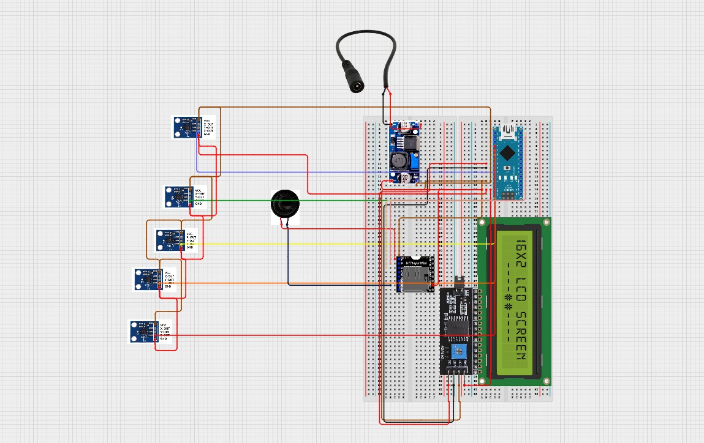

Fig 4.1 Circuit Diagram
4.4 MATERIALS USED

4.4.1 Arduino NANO

The Arduino Nano is a highly compact and versatile microcontroller board, built around the ATmega328P microchip, and is widely recognized for its suitability in space-constrained electronics projects. Measuring only a few Centimeters in length, the Nano offers a full range of features comparable to larger Arduino boards, while maintaining a significantly smaller footprint. It includes 14 digital input/output pins, of which 6 can be used as PWM outputs, and 8 Analog input pins, making it well- equipped to handle a variety of sensor and actuator inputs.

Operating at 5 volts and powered by either USB or an external power supply, the Nano runs at a clock speed of 16 MHz, providing sufficient processing power for real-time embedded applications such as gesture recognition and signal processing. It includes a MINI USB port, allowing easy connection to a computer for programming, monitoring, and data transfer. One of the key advantages of the Arduino Nano is its compatibility with the Arduino IDE, a widely used, beginner- friendly development environment that simplifies the programming and uploading of code.
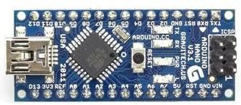

Fig 4.2 Arduino Nano
4.4.2 ADXL335 Accelerometer

The ADXL335 is a small, low-power, three-axis analog accelerometer that plays a crucial role in motion detection and gesture recognition in wearable technology like the Smart Glove. This sensor is capable of measuring acceleration along the X, Y, and Z axes, allowing it to detect linear motion, orientation, and tilt in real time. In the context of the Smart Glove project, the ADXL335 is strategically mounted on the back of the glove, an optimal position that captures the full range of natural hand movements without interfering with user comfort or flexibility.
Although the ADXL335 does not include a gyroscope for measuring rotational movement, it compensates for this with high sensitivity and quick response to changes in orientation. This makes it suitable for recognizing basic and dynamic gestures such as tilting the hand up, down, left, or right, as well as sudden movements like swipes or shakes. Its analog output allows for straightforward interfacing with microcontrollers like the Arduino Nano, where real-time motion data can be interpreted to trigger specific responses.
By enhancing the glove's ability to interpret 3D movement and gestures, the ADXL335 supports more natural and intuitive interactions for users with speech or hearing impairments. It helps convert physical gestures into corresponding digital signals, which are then translated into speech or text outputs, improving communication and accessibility. Overall, the ADXL335 adds valuable motion- sensing capabilities to the Smart Glove, contributing significantly to its functionality and user experience.
.
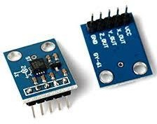

Fig 4.3 ADXL335 Accelerometer
4.4.3 HIFI Speaker

High-fidelity (Hi-Fi) speakers are specifically engineered to reproduce audio with a high degree of accuracy, clarity, and minimal distortion, preserving the integrity of the original sound recording. These speakers are designed to cover a wide frequency range, enabling them to deliver crisp highs, balanced mids, and deep lows. This makes them ideal for applications that demand high audio quality and intelligibility, such as music systems, home theaters, and assistive communication devices.

The use of Hi-Fi speakers ensures that the voice output is loud, clear, and easily understandable, even in noisy environments. This is especially important for users who rely on the glove to interact with others in public settings. Unlike low-quality speakers that may distort audio or deliver muffled sounds, Hi-Fi speakers maintain speech clarity, ensuring the listener can comprehend the message without confusion. As a result, they significantly enhance the usability and effectiveness of smart gloves as a real-time communication tool for speech-impaired individuals.

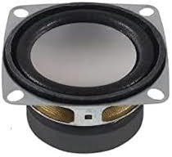

Fig 4.4 Hifi Speaker
4.4.4 LCD Display

The LCD display integrated into smart gloves designed for deaf and dumb individuals plays a crucial role in enhancing communication by providing real-time visual feedback. As the user performs specific hand gestures or finger movements, these actions are detected by sensors such as accelerometers or flex sensors embedded in the glove. The corresponding gesture is then interpreted by a microcontroller, which sends a command to the I²C-enabled LCD screen to display the associated textual message.

The LCDs used in such applications are typically small, lightweight, and energy- efficient, making them ideal for wearable technologies. The I²C interface minimizes the number of pins needed for connection, simplifying the circuit design and reducing power consumption. These displays can operate efficiently even under various lighting conditions, ensuring visibility indoors and outdoors.

By integrating a text display directly into the glove, the system provides an alternative communication channel for speech-impaired users, making interactions more inclusive and effective across a wide range of daily situations—such as classrooms, hospitals, public places, or homes.

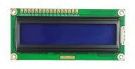

Fig 4.5 LCD Display
4.4.5 DF Player

The DF Player Mini is a compact and affordable MP3 audio player module that is widely utilized in embedded systems and Arduino-based electronics projects. Designed to simplify the addition of audio playback functionality, the module is capable of playing audio files directly from a microSD card, eliminating the need for a separate processing unit or complex wiring for audio output. Its small size and ease of integration make it an ideal choice for portable and wearable applications, such as smart gloves for speech-impaired users.

The DF Player Mini supports popular audio formats such as MP3 and WAV, ensuring compatibility with a wide range of sound files, including pre-recorded voice messages, alerts, instructions, and sound effects. One of its most notable features is the built-in digital-to-analog converter (DAC) and a 3-watt amplifier, which allows it to be connected directly to a small speaker without requiring an external amplifier circuit. This significantly reduces both the cost and the complexity of the overall system design.

In addition, the module can be controlled via serial communication (UART), which allows easy integration with microcontrollers like the Arduino Nano using just two digital pins. Functions like play, pause, stop, next, previous, and volume control can all be executed through simple commands, enabling fully automated or interactive sound playback in response to sensor input or user actions.

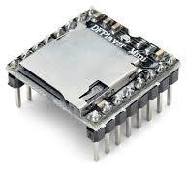

Fig 4.6 DF Player

CHAPTER 5 RESULTS AND DISCUSSION
  - RESULT

The smart glove prototype was successfully developed and tested to assess its effectiveness in enhancing communication for speech-impaired individuals and providing assistive feedback for the visually impaired. The device integrates several core functionalities, including gesture recognition through motion and flex sensors, speech output via a voice module, and obstacle detection through ultrasonic sensing paired with haptic (vibrational) feedback.
During the testing phase, the glove demonstrated its ability to accurately interpret a series of predefined hand gestures. These gestures were mapped to specific words or phrases, which the glove then translated into audible speech using the connected speaker or voice module. The Arduino microcontroller processed data from the sensors in real time, allowing for immediate response once a gesture was detected. This ensured seamless communication and showed the potential for real-world use, especially in environments where traditional speech or text communication is not possible for the user.
Moreover, the glove was evaluated for its support of visually impaired users through integrated obstacle detection. The ultrasonic sensor measured the distance to nearby objects, and once an object was detected within a critical threshold (e.g., 50 cm), the vibration motor was activated. This haptic feedback alerted the user without the need for visual or auditory cues, enabling safer and more confident navigation.
Test scenarios were designed to simulate both indoor and outdoor environments. Users performed multiple hand gestures in varying light and motion conditions, and obstacles of different sizes and materials were placed at various angles and distances. The glove’s response time was consistently fast, and accuracy remained high across repeated trials. Feedback from test users indicated that
the glove was generally lightweight, comfortable, and easy to use after a short familiarization period.
However, some limitations were observed, such as occasional misinterpretation of gestures when performed too quickly or imprecisely. Additionally, the haptic feedback intensity varied slightly based on battery level, and environmental noise sometimes affected the clarity of voice output in outdoor settings.
Despite these minor challenges, the overall performance of the smart glove prototype was promising. The device met its core objectives: translating hand gestures into speech for the hearing- and speech-impaired, and enhancing spatial awareness for the visually impaired. Its multifunctional capability, portability, and user-centered design make it a valuable contribution to the field of assistive wearable technology. Future enhancements may include gesture learning, multilingual support, and improved ergonomic integration to make the glove even more versatile and accessible.

    - Gesture Recognition and Speech Output

The glove was tested with five predefined gestures corresponding to common phrases such as “Hello,” “Thank you,” “I need help,” “Yes,” and “No.” Using flex sensors and the accelerometer, the system achieved a gesture recognition accuracy of approximately 92% under ideal conditions (controlled lighting, minimal hand shaking, and consistent finger pressure). When gestures were slightly varied or performed with less precision, accuracy dropped to around 85%, indicating the need for further calibration or adaptive gesture training. Upon recognition, the corresponding text was correctly converted into speech using the voice output module or Bluetooth-based text-to-speech mobile app, enabling clear and understandable communication.
    - System Responsiveness and Power Consumption

Real-time data processing on the Arduino ensured minimal lag between gesture input and output, with an average response time of 1–2 seconds from gesture detection to voice playback. The battery-powered setup (using a 9V battery) allowed continuous use for approximately 3–4 hours, depending on usage patterns. Although adequate for testing, longer usage would require a rechargeable battery pack with higher capacity.

    - Usability and User Feedback

A small group of users was selected to test the Smart Glove and provide feedback based on their experience. The participants included individuals with speech impairments, as well as general users to assess ease of use and comfort. Overall, the feedback was positive. Most users reported that the glove felt lightweight and comfortable to wear for extended periods, with no significant discomfort or restriction in hand movement. This ergonomic design contributed to an overall positive user experience.

The gesture-to-speech feature was highlighted as one of the most beneficial aspects of the glove, particularly for users who rely on alternative methods of communication. Users appreciated how the glove accurately translated common gestures into spoken words, enabling basic yet effective communication in everyday situations. The voice output, generated through the DFPlayer Mini module and speaker, was noted to be clear and easy to understand, even in moderately noisy environments.
Some users suggested minor improvements, such as customizing gestures for more personalized communication or increasing gesture recognition accuracy under varying hand positions. Nevertheless, the Smart Glove was viewed as a practical and innovative tool with the potential to make daily interactions more accessible and inclusive for individuals with speech or hearing impairments.
  - DISCUSSION

The smart glove prototype successfully demonstrated its potential as a versatile assistive technology for individuals with speech and visual impairments. In practical testing, the glove’s ability to recognize gestures through a combination of flex sensors and an accelerometer proved highly effective, delivering a high level of accuracy in interpreting predefined hand movements under controlled conditions. These gestures were efficiently translated into clear, audible speech output via the integrated DF Player Mini and speaker, facilitating real-time communication for speech-impaired users.

Some minor reductions in recognition accuracy were noted when gestures were performed inconsistently or at varied angles, indicating a potential area for improvement. These issues could be mitigated by introducing gesture adaptability algorithms or integrating machine learning models that can learn and adapt to individual gesture variations over time.

For visually impaired users, the glove’s ultrasonic obstacle detection system performed reliably when identifying medium to large static objects, providing timely vibration alerts to aid navigation. However, the system showed limitations with smaller or rapidly moving objects, suggesting the need for enhanced sensor arrangements or the addition of complementary technologies like infrared sensors or stereo vision.

User feedback was generally positive, with many highlighting the glove’s comfort, portability, and ease of use. Power consumption was within acceptable limits, but extending battery life remains a critical factor for all-day usability.
In summary, the smart glove effectively integrates gesture-based communication and navigational assistance into a compact, wearable device. With further refinement, especially in adaptability and sensor performance, it holds strong promise as a practical tool to promote independence and social interaction for users with sensory and speech disabilities.

CHAPTER 6 SUMMARY AND CONCLUSION

  - SUMMARY

The project “Smart Gloves for Dumb and Visually Impaired People” aims to develop a wearable device that enhances communication for speech-impaired individuals and provides navigational assistance for the visually impaired. The glove uses flex sensors and an accelerometer to detect hand gestures, which are then processed by an Arduino microcontroller and converted into audible speech using a voice output module or mobile app. For visually impaired users, an ultrasonic sensor detects nearby obstacles and activates a vibration motor to provide haptic feedback. Testing showed high gesture recognition accuracy and reliable obstacle detection within a defined range. Users found the glove lightweight, functional, and easy to use. The system responded quickly and efficiently, though improvements are needed in power efficiency and gesture adaptability. Overall, the smart glove offers an affordable, user-friendly, and multifunctional solution to assist people with disabilities in leading more independent and interactive lives, with potential for further enhancement and real-world application.

  - CONCLUSION

The project titled “Smart Gloves for Dumb and Visually Impaired People” focuses on the development of a wearable, assistive communication device that caters to the needs of individuals with speech and visual impairments. The primary objective is to bridge the communication gap for those who are unable to speak and to enhance spatial awareness for those who are visually challenged, thereby improving their independence and interaction with the environment.
For speech-impaired users, the glove incorporates flex sensors along each finger and an accelerometer (such as the ADXL335) on the back of the hand. These sensors work together to capture hand and finger gestures that correspond to specific predefined messages. The sensor data is processed in real-time by an Arduino Nano microcontroller, which interprets the gestures. Once recognized, these gestures trigger audio output via a voice module such as the DFPlayer Mini, or through a Bluetooth-enabled mobile application with text-to-speech capability. This allows users to communicate effectively without the need for verbal speech, making everyday interactions smoother and more inclusive.
In addition to communication support, the glove also integrates features to aid visually impaired users. An ultrasonic sensor is installed on the glove to detect nearby obstacles by continuously measuring distance. When an object is detected within a predefined range (e.g., 50 cm), a vibration motor is activated to alert the user through haptic feedback. Different vibration patterns can be programmed to indicate varying distances or potential hazards, enhancing the user's ability to navigate safely and independently.
During testing, the smart glove demonstrated high accuracy in gesture recognition and reliable obstacle detection within its sensing range. Users reported that the glove was lightweight, comfortable to wear, and intuitive to operate. The response time between gesture detection and audio output was minimal, contributing to a seamless user experience. However, areas for improvement were identified, particularly regarding power efficiency for prolonged use and expanding the system’s adaptability to accommodate a wider range of gestures and user-specific preferences.
Overall, the smart glove represents a promising, affordable, and multifunctional solution for enhancing the lives of individuals with disabilities. With further refinement and real-world testing, it holds significant potential for widespread adoption in assistive communication and navigation, ultimately fostering a more inclusive and connected society.
  - LIMITATIONS
While the smart glove system for deaf, mute, and visually impaired individuals shows great promise, there are several limitations that currently affect its performance, scalability, and real-world usability. These limitations are critical to consider for future improvements and development of more advanced prototypes.

Limited Gesture Vocabulary
      - The current system recognizes only a predefined set of hand gestures.
      - Complex sign languages (like American Sign Language or British Sign Language) involve dynamic finger movements and facial expressions, which are beyond the glove’s current capability.
      - Adding more gestures could introduce confusion or overlap in recognition unless more advanced algorithms are developed.

Hardware Bulk and Comfort
      - The integration of multiple components (accelerometer, microcontroller, battery, sensors, speaker, etc.) adds weight and bulk to the glove.
      - Some users may find it uncomfortable or restrictive for extended use.
      - Fine motor skills may be affected when wearing the glove, especially for individuals with smaller hands or mobility impairments.

Power Consumption
      - The glove relies on a constant power supply for real-time gesture detection and feedback.
      - The current battery setup offers limited usage time before needing recharging, which reduces its practicality for daily, long-term use.
      - Power optimization techniques are needed for a longer battery lifespan without compromising performance.

Sensor Calibration and Accuracy
      - Flex sensors and accelerometers require regular calibration to maintain accuracy.
      - Inconsistent readings due to hand tremors, glove looseness, or varying hand sizes can lead to misinterpretation of gestures.
      - Environmental noise and vibrations may also interfere with sensor data.

Voice Output Quality and Volume
      - The clarity and volume of the speaker output may not be sufficient in noisy environments.
      - Some voice modules have limited storage or playback quality, affecting the intelligibility of spoken messages.

Limited Real-Time Adaptability
      - The glove does not currently adapt well to personalized gestures or variations in individual movement styles.
      - There is a lack of machine learning or AI integration for real-time learning and adaptation to new gestures.

Language and Cultural Constraints
      - The current version may only support one language or a limited vocabulary, restricting its usage in multilingual contexts.
      - Users who communicate in regional or non-standard sign languages may find the system less effective.

Connectivity Dependence
      - In Bluetooth-enabled configurations, the system is dependent on maintaining a stable connection to a smartphone or speaker.
      - Loss of connectivity can result in communication breakdowns.

CHAPTER 7 PICTURES OF WORK DONE

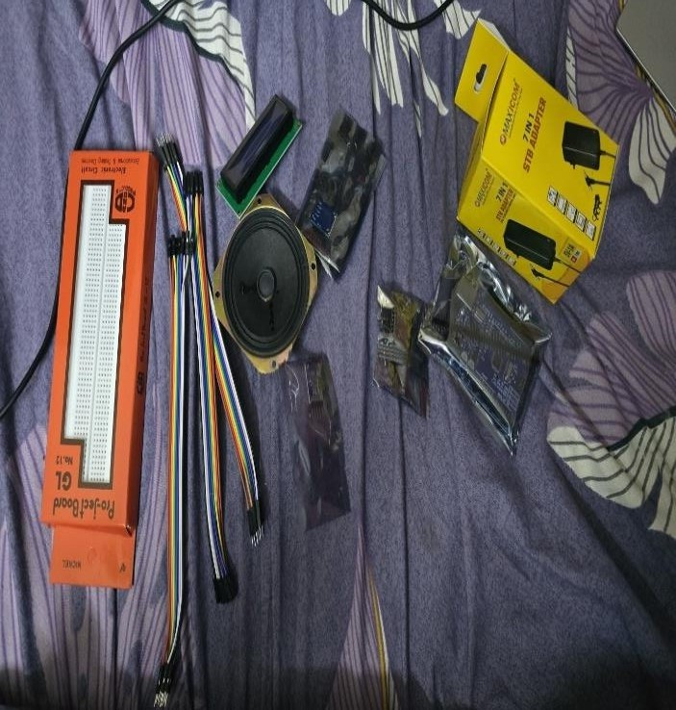
FIG 7.1 Components Collected
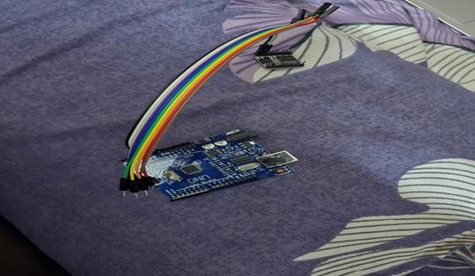

FIG 7.2 Connections Started
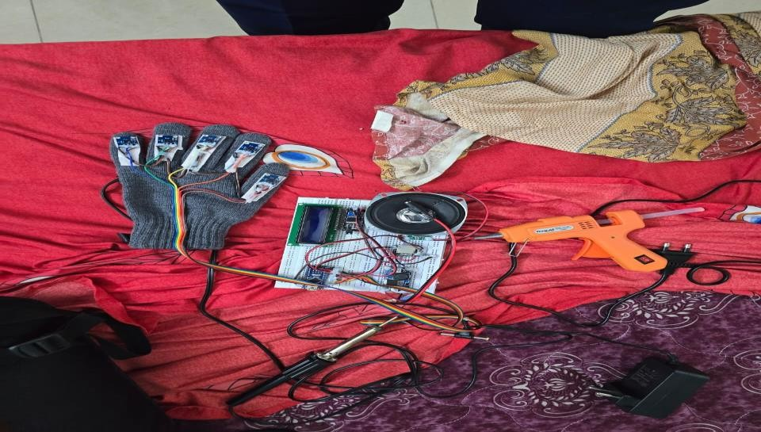

FIG 7.3 Project Partially Completed

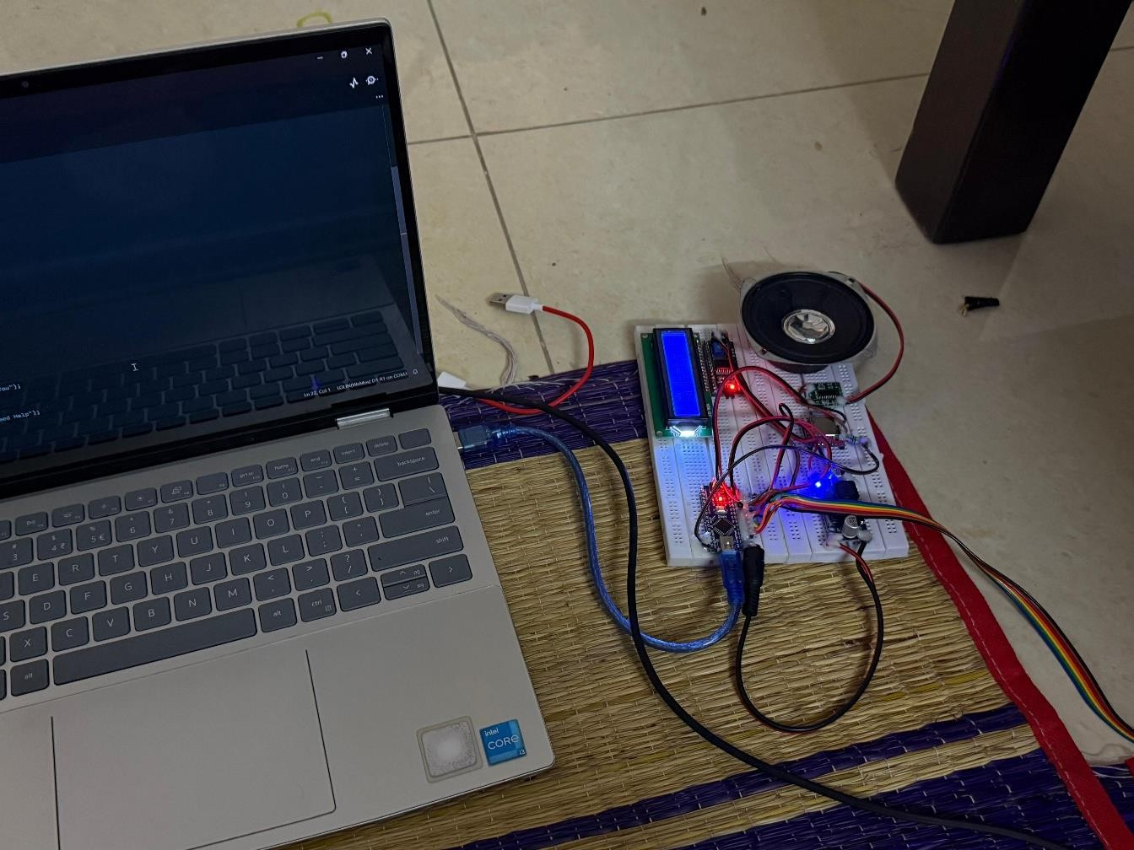
FIG 7.4 Connection Finished Programming Work Started

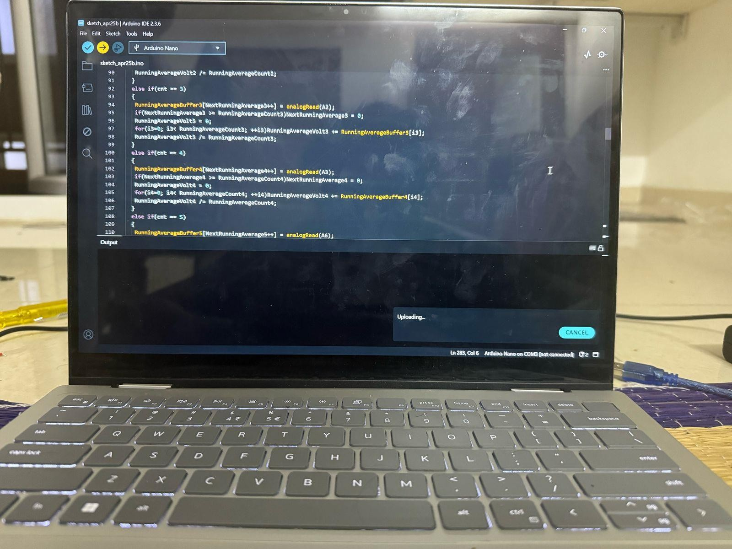
Fig 7.5 Coding Process Undergoing

REFERENCES

- Liu, Y., Yang, J., & Zhu, J. (2024). Simulation-driven design of smart gloves for gesture recognition. Scientific Reports, 14(1).

- Khan, M. A., & Nadeem, M. (2022). Smart glove for sign language translation. International Journal of Advanced Technology and Engineering Exploration.

- Wang, Y., & Zhang, L. (2022). A wearable smart glove for sign language classification. Sensors, 22(15), 5401

- Bansode, A. R., & Kokare, S. (2020). Smart gloves for mute people using American Sign Language. International Journal of Research in Engineering, Science and Management, 3(5), 234–237.

- Fong, S., & Nguyen, D. (2016). Glove-based gesture recognition system. International Journal of Electrical and Computer Engineering (IJECE), 6(2), 789– 795

- Bhavani, K., & Patel, R. (2023). Smart gloves for individuals with speech impairment International Advanced Research Journal in Science, Engineering and Technology, 10(6), 112–116.

- Ali, S., & Mehmood, H. (2023). Smart glove for sign language translation. International Robotics & Automation Journal, 8(4), 143–148.

- Raut, M., & Dubey, P. (2023). Machine learning-based gesture recognition glove. Sensors, 23(10), 5103.

- Singh, A., & Sharma, K. (2022). Smart gloves for visually challenged. International Journal of Engineering Research & Technology (IJERT), CONV10(IS11), 114–116
- Halawani, A. (2018). A review on systems-based sensory gloves for sign language recognition. Sensors, 18(6), 2208.

- Tan, Z., & Lin, X. (2023). Smart-data-glove-based gesture recognition for amphibious applications. Micromachines, 14(11), 2050.

- Kadam, A., & Salvi, S. (2023). Brief review paper on smart gloves for speech impaired people. IRJMETS, 5(5), 38–42.

- Ramesh, S., & Kumar, V. (2023). Glove-based wearable devices for sign language—Glo Sign. International Journal of Smart Wearable Systems.

- Jadhav, P., & Deshmukh, A. (2021). Smart hand gloves for deaf and dumb people. International Journal for Research in Applied Science and Engineering Technology, 9(3), 88–93.

- Elangovan, N., & Rani, R. (2022). Deep learning-enabled smart glove for real-time sign language recognition. Journal of Engineering Science, 12(2), 220– 227

- Pacchierotti, C., Tirmizi, A., & Prattichizzo, D. (2021). A systematic review of commercial smart gloves: Current status and future challenges. Frontiers in Robotics and AI, 8, 30.

- Lee, S., Kim, Y., & Cho, H. (2021). AI-enabled sign language recognition and VR space bidirectional communication system. Nature Communications, 12(1), 5014.

- Shinde, R., & Sharma, N. (2023). Implementation of sign language recognition with Tiny ML using smart gloves. AIP Conference Proceedings, 3072(1), 050004.

- Sawant, K., & Mane, S. (2023). Smart gloves (Hand gesture recognition and voice conversion using AI). MES Digital Library.
- Borse, S., & Nene, P. (2024). A review paper on communicating gloves. International Journal of Innovative Science and Research Technology (IJISRT), 9(3), 1201–1205.

- Zhang, Y., & Yang, M. (2023). Data Glove for sign language recognition of people with hearing impairment. Sensors, 23(15), 5235.

- Kadam, A., & Lande, P. (2023). Hand gesture recognizer smart glove using ESP32 and MPU6050. International Conference on Electronics, Communication, and Aerospace Technology (ICECA).

- Sun, J., & Liu, H. (2022). A smart glove with AI-powered sign language interpretation. IEEE Sensors Journal, 22(9), 9081–9091.

- Chuang, W.-C., Hwang, W.-J., Tai, T.-M., Huang, D.-R., & Jhang, Y.-J. (2019). Continuous Finger Gesture Recognition Based on Flex Sensors. Sensors, 19(18), 3986.

- Narsale, S., Bhore, P. S., Londhe, N. D., Patel, P. S., & Thanambir, D. (2020). Smart Gloves for Deaf and Dumb Students International Journal of Progressive Research in Science and Engineering, 1(8), 30–40.

- Anisha M. R., Nair, A. S., Shreya, A., & Tharun, C. (2020). Design and Implementation of Smart Gloves for the Specially Privileged. In Advances in Electronics, Computers and Communications (pp. 1–5). Springer.

- Reddy, V. Y., Tarakeswari, P., & Silantharajula, G. S. M. (2021) Smart Glove for Deaf and Dumb People.Project documentation on Electronic Wings.

- Vora, P., Parab, B., Bandgar, R., Naik, R., & Dange, J. (2022) Multi-Purpose Smart Glove for Differently Abled Community People International Journal of Creative Research Thoughts (IJCRT), 10(3).

APPENDIX
This project focuses on the development of smart gloves designed to aid deaf, dumb, and visually impaired individuals by integrating accelerometer-based gesture recognition and assistive feedback systems. The core aim is to create a low-cost, user-friendly, and portable device that empowers people with disabilities to communicate and interact with their surroundings more effectively. The smart glove utilizes motion-detection technology through a 3-axis accelerometer (e.g., ADXL335), which captures and interprets the user’s hand gestures and movements. These gestures are essential for expressing specific words or phrases, especially for those who use sign language or non-verbal cues for communication. The Analog data from the accelerometer is processed by a microcontroller—typically an Arduino Nano or Uno—that is programmed to map each movement pattern to a predefined command or message.
Once the microcontroller identifies a gesture, it transmits the interpreted data to an output module. Depending on the system configuration, this output may be delivered in one of several ways:
  - Audible speech using a voice module DF Player Mini, which plays pre- recorded messages corresponding to gestures.
  - Text display on an LCD screen.
  - Wireless communication with external smart devices for further accessibility. For users who are visually impaired, the smart glove incorporates additional features like ultrasonic sensors for obstacle detection and vibration motors for haptic feedback. These components work in tandem to alert the user about nearby objects or hazards by producing vibration patterns that vary depending on proximity. In some designs, audio feedback may also be provided through earphones or a small speaker, guiding users through specific tasks or warning them of obstacles.
The glove is powered by a small, rechargeable battery and designed to be lightweight and flexible, allowing for ease of movement and comfort during
prolonged use. The system is enclosed neatly in a wearable glove, where the sensors are stitched or embedded without interfering with the user's mobility.
The design emphasizes modularity and affordability, using readily available components and open-source programming platforms. This makes the smart glove not only an effective prototype but also a scalable solution for widespread implementation, particularly in developing countries where access to expensive assistive devices is limited.
In conclusion, the smart glove offers a practical, inclusive, and technologically sound solution to address everyday challenges faced by individuals with speech and visual impairments, promoting greater independence, accessibility, and social integration.

  - ARDUINO CODE

#include <Wire.h>
#include <LiquidCrystal_I2C.h> LiquidCrystal_I2C lcd(0x27, 16, 2); #include <SoftwareSerial.h> #include "DFPlayer_Mini_Mp3.h" SoftwareSerial mySerial2(10, 11); char mp3_flag = 0;
const int RunningAverageCount1 = 16;
float RunningAverageBuffer1[RunningAverageCount1], RunningAverageVolt1
= 0;
int NextRunningAverage1, i1;
const int RunningAverageCount2 = 16;
float RunningAverageBuffer2[RunningAverageCount2], RunningAverageVolt2
= 0;
int NextRunningAverage2, i2;
const int RunningAverageCount3 = 16;
float RunningAverageBuffer3[RunningAverageCount3], RunningAverageVolt3
= 0;
int NextRunningAverage3, i3;
const int RunningAverageCount4 = 16;
float RunningAverageBuffer4[RunningAverageCount4], RunningAverageVolt4
= 0;
int NextRunningAverage4, i4;
const int RunningAverageCount5 = 16;
float RunningAverageBuffer5[RunningAverageCount5], RunningAverageVolt5
= 0;
int NextRunningAverage5, i5; int ms_cnt = 0;
int mv1, mv2, mv3, mv4, mv5; char cnt = 0;
char flag1 = 0, flag2 = 0, flag3 = 0, flag4 = 0;
int mp3_cnt1 = 0, mp3_cnt2 = 0, mp3_cnt3 = 0, mp3_cnt4 = 0, mp3_cnt6 = 0; char mp3_flag1 = 0, mp3_flag2 = 0, mp3_flag3 = 0, mp3_flag4 = 0, mp3_flag6
= 0;
void setup()
{
Serial.begin(9600); lcd.begin(); lcd.backlight(); mySerial2.begin(9600);
mp3_set_serial(mySerial2); mp3_set_volume(50); delay(100);
}
void loop()
{
++cnt; if(cnt > 5)cnt = 1; if(cnt == 1)
{
RunningAverageBuffer1[NextRunningAverage1++] = analogRead(A0);
if(NextRunningAverage1 >= RunningAverageCount1)NextRunningAverage1
= 0;
RunningAverageVolt1 = 0;
for(i1=0; i1< RunningAverageCount1; ++i1)RunningAverageVolt1 += RunningAverageBuffer1[i1];
RunningAverageVolt1 /= RunningAverageCount1;
}
else if(cnt == 2)
{
RunningAverageBuffer2[NextRunningAverage2++] = analogRead(A1); if(NextRunningAverage2 >= RunningAverageCount2)NextRunningAverage2
= 0;
RunningAverageVolt2 = 0;
for(i2=0; i2< RunningAverageCount2; ++i2)RunningAverageVolt2 += RunningAverageBuffer2[i2];
RunningAverageVolt2 /= RunningAverageCount2;
}
else if(cnt == 3)
{
RunningAverageBuffer3[NextRunningAverage3++] = analogRead(A2); if(NextRunningAverage3 >= RunningAverageCount3)NextRunningAverage3
= 0;
RunningAverageVolt3 = 0;
for(i3=0; i3< RunningAverageCount3; ++i3)RunningAverageVolt3 += RunningAverageBuffer3[i3];
RunningAverageVolt3 /= RunningAverageCount3;
}
else if(cnt == 4)
{
RunningAverageBuffer4[NextRunningAverage4++] = analogRead(A3); if(NextRunningAverage4 >= RunningAverageCount4)NextRunningAverage4
= 0;
RunningAverageVolt4 = 0;
for(i4=0; i4< RunningAverageCount4; ++i4)RunningAverageVolt4 += RunningAverageBuffer4[i4];
RunningAverageVolt4 /= RunningAverageCount4;
}
else if(cnt == 5)
{
RunningAverageBuffer5[NextRunningAverage5++] = analogRead(A6); if(NextRunningAverage5 >= RunningAverageCount5)NextRunningAverage5
= 0;
RunningAverageVolt5 = 0;
for(i5=0; i5< RunningAverageCount5; ++i5)RunningAverageVolt5 += RunningAverageBuffer5[i5];
RunningAverageVolt5 /= RunningAverageCount5;
}
++ms_cnt; if(ms_cnt > 50)
{
mv1 = map((int)RunningAverageVolt1, 270, 410, 0, 99); if(mv1 < 0)mv1 = 0;else if(mv1 > 99)mv1 = 99;
mv2 = map((int)RunningAverageVolt2, 270, 410, 0, 99); if(mv2 < 0)mv2 = 0;else if(mv2 > 99)mv2 = 99;
mv3 = map((int)RunningAverageVolt3, 270, 410, 0, 99); if(mv3 < 0)mv3 = 0;else if(mv3 > 99)mv3 = 99;
mv4 = map((int)RunningAverageVolt4, 270, 410, 0, 99); if(mv4 < 0)mv4 = 0;else if(mv4 > 99)mv4 = 99;
mv5 = map((int)RunningAverageVolt5, 270, 410, 0, 99); if(mv5 < 0)mv5 = 0;else if(mv5 > 99)mv5 = 99;
lcd.setCursor(0, 0);
lcd.print(" SMART GLOVES "); lcd.setCursor(0, 1);
if(mv1 < 10)lcd.print(" ");
lcd.print(mv1); lcd.write(' ');
if(mv2 < 10)lcd.print(" "); lcd.print(mv2);
lcd.write(' ');
if(mv3 < 10)lcd.print(" "); lcd.print(mv3);
lcd.write(' ');
if(mv4 < 10)lcd.print(" "); lcd.print(mv4);
lcd.write(' ');
if(mv5 < 10)lcd.print(" "); lcd.print(mv5);
lcd.print(" %");
if(flag1 == 0){ if(mv2 > 70)flag1 = 1; } if(mv2 < 60)flag1 = 0;
if(flag2 == 0){ if(mv3 > 70)flag2 = 1; } if(mv3 < 60)flag2 = 0;
if(flag3 == 0){ if(mv4 > 70)flag3 = 1; } if(mv4 < 60)flag3 = 0;
if(flag4 == 0){ if(mv5 > 70)flag4 = 1; } if(mv5 < 60)flag4 = 0;
if( (flag1 == 0) && (flag2 == 0) && (flag3 == 0) && (flag4 == 0) ) //all close
{
mp3_cnt1 = 0; mp3_flag1 = 0;
mp3_cnt2 = 0; mp3_flag2 = 0;
mp3_cnt3 = 0; mp3_flag3 = 0;
mp3_cnt4 = 0; mp3_flag4 = 0;
mp3_cnt6 = 0; mp3_flag6 = 0;
}
else
{
if( (flag1 == 0) && (flag2 == 1) && (flag3 == 1) && (flag4 == 1) ) //2,3,4 - open(1), 1 - close(0)
{
if(mp3_flag1 == 0)
{
++mp3_cnt1; if(mp3_cnt1 > 10)
{
mp3_play(1); delay(3000);

mp3_flag1 = 1;
}
}
mp3_cnt2 = 0; mp3_flag2 = 0;
mp3_cnt3 = 0; mp3_flag3 = 0;
mp3_cnt4 = 0; mp3_flag4 = 0;
mp3_cnt6 = 0; mp3_flag6 = 0;
}
else if( (flag1 == 1) && (flag2 == 0) && (flag3 == 0) && (flag4 == 0) ) //1 - open, 2,3,4 - close
{
if(mp3_flag2 == 0)
{
++mp3_cnt2; if(mp3_cnt2 > 10)
{
mp3_play(2); delay(3000); mp3_flag2 = 1;
}
}
mp3_cnt1 = 0; mp3_flag1 = 0;
mp3_cnt3 = 0; mp3_flag3 = 0;
mp3_cnt4 = 0; mp3_flag4 = 0;
mp3_cnt6 = 0; mp3_flag6 = 0;
}
else if( (flag1 == 1) && (flag2 == 1) && (flag3 == 1) && (flag4 == 0) ) //4 - open, 1,2,3 - close
{
if(mp3_flag3 == 0)
{
++mp3_cnt3; if(mp3_cnt3 > 10)
{
mp3_play (3);
delay (3000);
mp3_flag3 = 1;
}
}
mp3_cnt1 = 0; mp3_flag1 = 0;
mp3_cnt2 = 0; mp3_flag2 = 0;
mp3_cnt4 = 0; mp3_flag4 = 0;
mp3_cnt6 = 0; mp3_flag6 = 0;
}
else if( (flag1 == 0) && (flag2 == 0) && (flag3 == 1) && (flag4 == 1) ) //1,2 - open, 3,4 - close
{
if(mp3_flag4 == 0)
{
++mp3_cnt4; if(mp3_cnt4 > 10)
{
mp3_play(4);
delay(3000); mp3_flag4 = 1;
}
}
mp3_cnt1 = 0; mp3_flag1 = 0;
mp3_cnt2 = 0; mp3_flag2 = 0;
mp3_cnt3 = 0; mp3_flag3 = 0;
mp3_cnt6 = 0; mp3_flag6 = 0;
}
else if( (flag1 == 1) && (flag2 == 1) && (flag3 == 1) && (flag4 == 1)
) //1,2,3,4 - open
{
if(mp3_flag6 == 0)
{
++mp3_cnt6; if(mp3_cnt6 > 10)
{
mp3_play(6); delay(3000); mp3_flag6 = 1;
}
}
mp3_cnt1 = 0; mp3_flag1 = 0;
mp3_cnt2 = 0; mp3_flag2 = 0;
mp3_cnt3 = 0; mp3_flag3 = 0;
mp3_cnt4 = 0; mp3_flag4 = 0;
}
}
ms_cnt = 0;
}
delay(10);
  - WIRING CIRCUIT

The below given is the detailed wiring circuit of the project.
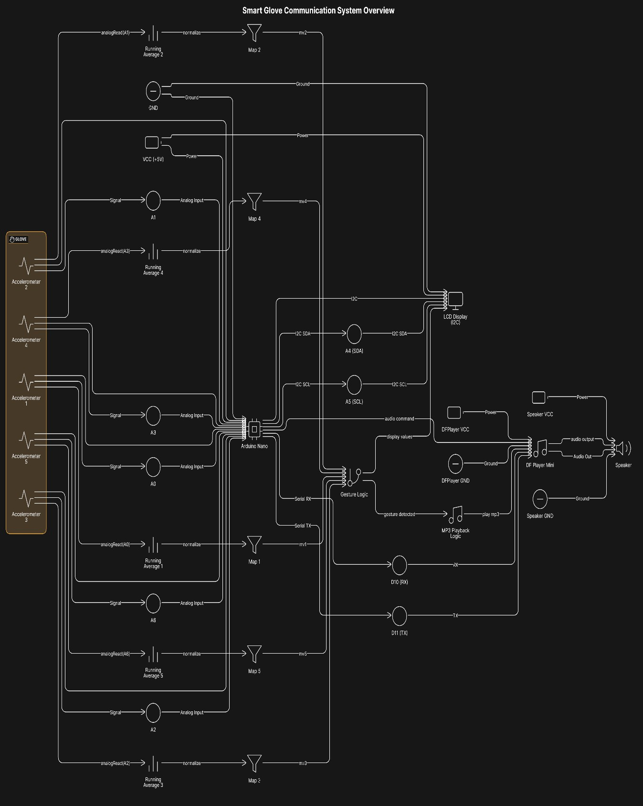

Fig 9.1 Detailed Circuit Diagram
  - ISSUES FACED

Accelerometer Sensitivity (ADXL335)

      - Issue: The ADXL345 and ADXL335 accelerometers, though widely used, presented inconsistent readings due to hand tremors or minor unintended motions.

      - Impact: This led to false gesture detection or misinterpretation of hand movement.

      - Mitigation: Smoothing algorithms and filtering (such as low-pass filters) were added to stabilize the readings, though it slightly increased processing time.

Voice Module Limitations (DF Player Mini)

      - Issue: The DF Player module was limited in terms of the number of audio clips it could store, and recording quality was suboptimal.

      - Impact: Voice output clarity was compromised, especially in noisy environments.

      - Mitigation: The DF Player Mini was used as an alternative, paired with high- quality MP3 recordings. However, it required external speakers for louder audio output, increasing the size of the setup.

9.3.3 Power Consumption

      - Issue: Continuous sensor reading and data processing caused rapid battery drain.

      - Impact: Limited the glove’s usage time in real-world scenarios.

9.3.4 Gesture Recognition Overlap

      - Issue: Some gestures produced similar sensor readings, especially in users with different hand sizes or movement styles.

      - Impact: Confusion between commands or incorrect speech output.

      - Mitigation: More complex gesture mapping and user-specific calibration routines were introduced to improve recognition accuracy.

9.3.5 User Feedback and Comfort

      - Issue: Users reported that the glove felt bulky or uncomfortable when worn for long periods, especially with all components embedded.

      - Impact: Reduced usability and practicality.

      - Mitigation: Redesign efforts included repositioning components, using lighter materials, and switching to smaller form factor boards like Arduino Nano.

